**Emergency Preparedness Supplies: Emergency Classroom Backpack**

*This list is in no way a directive from the district or PTSA council. This list is a* ***suggestion*** *of items to have on hand for emergency situations. PrepareSmart has supplied many LWSD schools with emergency backpacks. Standard backpacks contain (1) plastic whistle, (30) non-antiseptic wipes, (1) anti-fog goggles, (1) first aid kit, (3) AA batteries, (1) clipboard, (5) pairs nitrile gloves, (2) emergency blanket, (5) biohazard bags, (1) LED flashlight*

*(1) leather gloves, (1) toilet paper, (1) note pad, (1) black marker, (1) printed red backpack,*

School: Approx. # Students + Staff:

Completed by (*names*): Date:

Classroom Backpacks are (*check all that apply*):  Taken outside during evacuations

▪ In every classroom  In common areas (gym, cafeteria)  Assigned to area/room, not staff member

**First Aid Kit**

Type (Qty): Nitrile Gloves ( )  Gauze ( ) Medical Tape ( )  Triangle Bandages ( )  Scissors ( )

▪ Band-Aids™ ( )  N95 Respirator Mask/Dust Mask(1 for Teacher) ( )

**Sanitation**

Type (Qty):  Toilet Paper ( )  Fem. Hygiene ( )  Hand Sanitizer/Antiseptic wipes ( )  Trash Bags ( )

Note

:

**Comfort**

Type (Qty):  Emergency Blanket ( )  Poncho(1 for teacher) ( )  Light Stick ( )

Note

:

**Office Supplies**

Type (Qty):  Student Roster  Pens / Pencils ( )  Sharpie ( )  Paper Pad ( )  Clipboard ( )

Type (Qty):  Red “Help”/Green “OK” Card ( )  Flashlight w/batteries ( )  Duct Tape ( )

Note: ____________________________________________________________________________________________

**Emergency Preparedness Supplies: Lockdown Bucket**

School: Room:_____________ Completed by (*names*):_______________________ Date:________

*This list is in no way a directive from the district or PTSA council. This list is a* ***suggestion*** *of items to have on hand for emergency situations. 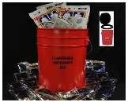PrepareSmart has supplied many LWSD schools with lockdown buckets. Standard buckets contain (1) Port-a-Potty bucket and seat, (1) roll toilet paper, (1) 4 oz bottle hand sanitizer*

*(3) Restop Waste Kits, (24) 4.2 oz water pouches, (2) 2400 calorie food bars, 6 portions per bar*

Lockdown Buckets have (*check all that apply*):

▪ Lid /Seat  Classroom label

**Water**

**(**

**Potable**

**)**

Storage Method (Qty):  Plastic bottles ( )  Pouches ( )  Cups ( )

Other:

Rations Bars?  Yes  No Brand Name: # of packages ( ) # of portions per package ( )

**Food**

Note:

**Sanitation**

Type (Qty):  Toilet Paper ( )  Hand Sanitizer/Wipes ( )  Trash Bags ( )  Toilet Waste Disposal Bags-WAG ( )

Note:

**Emergency Preparedness Supplies: Main Storage**

School: Approx. # Students + Staff:

Completed by (*names*): Date:

* Supplies are stored in:  Outside Storage Container  Inside Closet  Other:

**Water**

**(**

**Potable**

**)**

Storage Method (Qty):  Plastic bottles ( ) Pouches ( )  Mylar bags in box ( ) Blue barrel ( )

Qty: Water Filter?  Yes  No

**Food**

Rations Bars?  Yes  No Brand Name: # of 2400cal bars ( )

# of 400 Cal bars ( )

Note

**Basics**

Type (Qty):  Flashlight ( )  Battery Powered AM/FM Radio ( )  NOAA Weather Radio  Batteries ( )

Note

:

**First Aid**

Red or Blue Trauma Bag?  Yes  No  First Aid Tent ( )  CPR Shield ( )

Type (Qty):  Nitrile Gloves ( )  Gauze Pads/Compress Dressings ( )  Gauze rolls ( )  Medical Tape ( )

▪ Scissors ( )  Roller Bandages ( )  Breathing Barrier(one-way) ( )  Thermometer(non-mercury/non-glass) ( )

▪ Triangle Bandages ( )  Adhesive bandages ( )  Antiseptic wipes ( )  Cold Compress (  First Aid Guide ( )

▪ Portable Potty ( )  Toilet Paper ( )  Fem. Hygiene ( )  Hand Sanitizer/wipes ( )  Trash Bags ( )

**Sanitation**

▪ Toilet Waste Disposal Bags (WAG bags/Rest Stop gelling kit) ( )

Note

:

**Shelter**

Type (Qty): Tent / Canopy ( )  Tarp ( )  Rope / Zip Ties ( )  Blankets ( )  Duct Tape ( )

Note

:: 

**Command Center**

▪ Bullhorn ( )  School Maps ( )  Evacuation plan map ( )  Pens ( )  Paper Pads ( )

Note:

**Student**

**-**

**Parent Reunification**

Type (Qty):  LWSD Forms ( )  Copy Student Emergency Contact Cards ( )  Alpha Student Roster ( )  Runner Forms ( )  Clipboard / Pens ( )  Signage ( )  Tape ( )  Sharpies ( )

Note:

*+This list is in no way a directive from the district or PTSA council. This list is a suggestion of items to have on hand for emergency situations.*

## Water

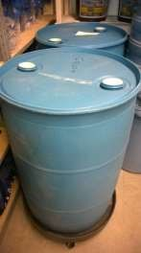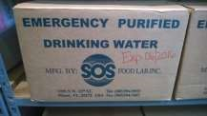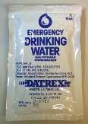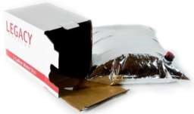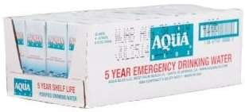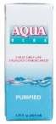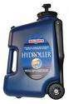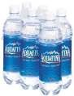

## Food

* Rations Bars could be: Millennium Bars, Datrex Bars, Coast Guard / Life Boat Rations, etc.

Servings Info

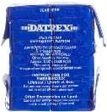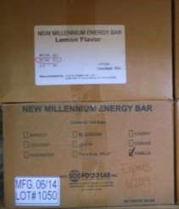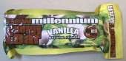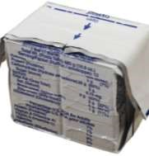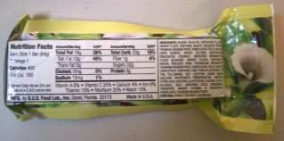

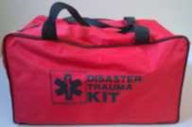

## First Aid

The Red Trauma Bag may have been provided to most schools at some point, but also may be out of date.

## Sanitation

The “Luggable Loo” is one brand of portable potty. Is your store of feminine hygiene products modern? Toilet Waste

Disposal Bag brands include “Double Doody”, “Wag Bag”, and “Restop Waste”.

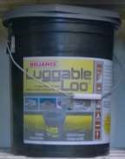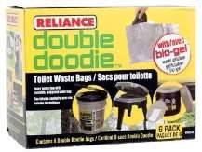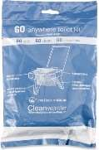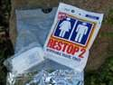

## Shelter

Tarps are often blue. Rope or Zip Ties can be used to hang tarps. Fabric blankets may be wool, velour, Mylar or any other

